<https://public.tableau.com/app/profile/salim.malik3338/viz/Project1-ComparativeStudyofCountries_16707769554820/Dashboard?publish=yes>

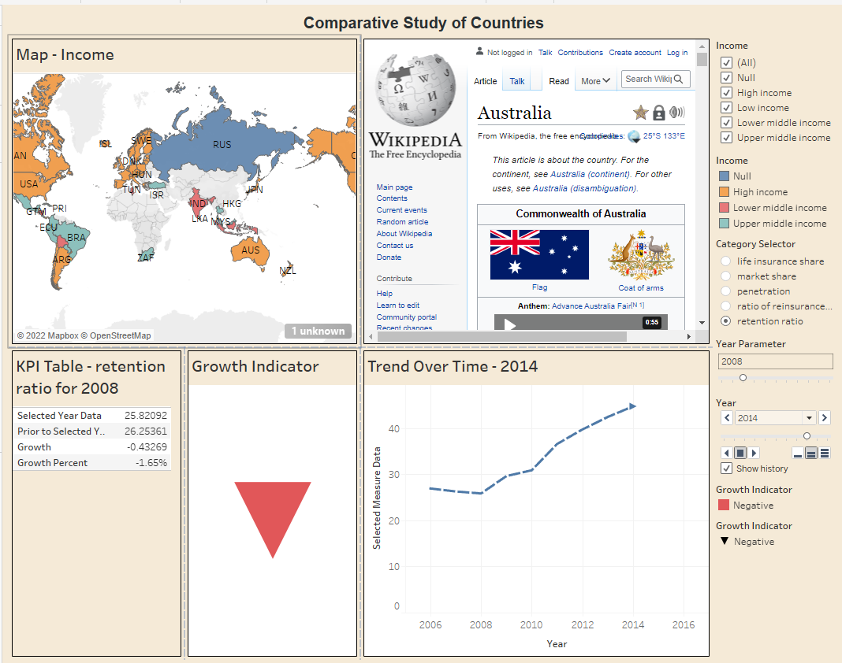

Write Up:

Some observations noted from the study just for reference:

For Australia,

Retention Ratio for year 2008:

Selected year Data: 0.85749

Prior to Selected year to Data: 0.86827

Growth: -0.01078

Growth Percent: -1.24%

Growth Indicator is Negative shows red colour bottom arrow

For United States,

Retention Ratio for year 2008:

Selected year Data: 0.72676

Prior to Selected year to Data: 0.72846

Growth: -0.00170

Growth Percent: -0.23%

Growth Indicator is Negative shows red colour bottom arrow

For Japan,

Retention Ratio for year 2009:

Selected year Data: 0.93938

Prior to Selected year to Data: 0.92479

Growth: 0.01459

Growth Percent: 1.58%

Growth Indicator is Positive shows green colour Up arrow